Change/tighten/loosen collet in Carlo Di Ge Giorgi Handpiece
- Insert a pin into the hole at the base of the handpiece, ensuring it threads all the way through. You may need to hold this in position:
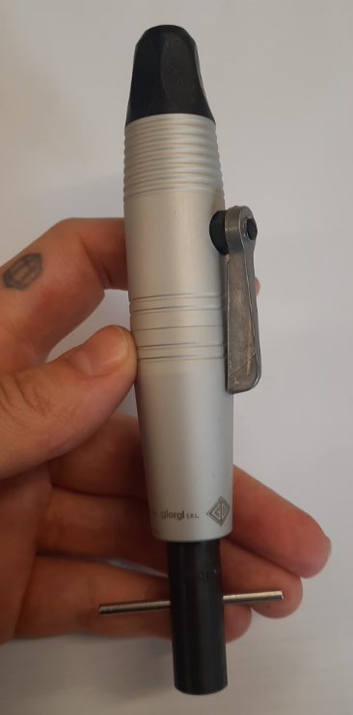

- Unscrew black cone piece from top of handpiece:
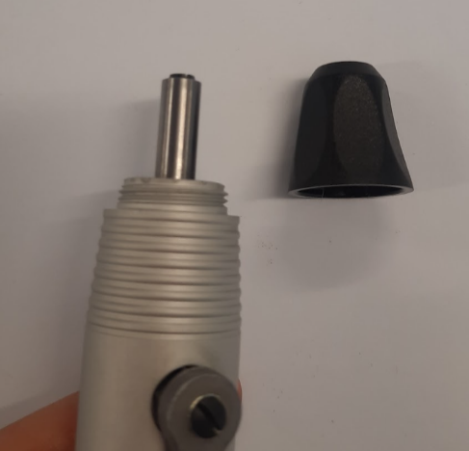

- Open the lever to right degree angle, which will also open the collet:
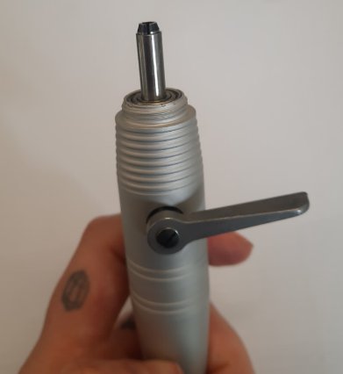

- Insert a 1.5mm allen key into the collet and rotate a quarter turn anti-clockwise. You should feel a screw loosen.
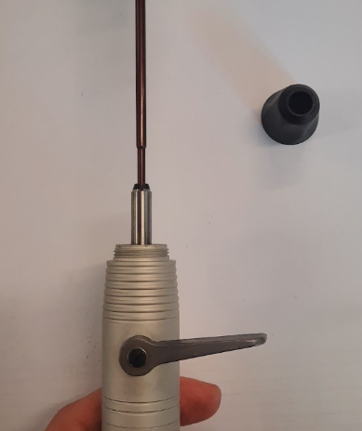

- Once loose, the collet should be able to be loosened in and out by hand. You are now able to remove it entirely by rotating the collet anti-clockwise. You are able to tighten it by rotating it clockwise:
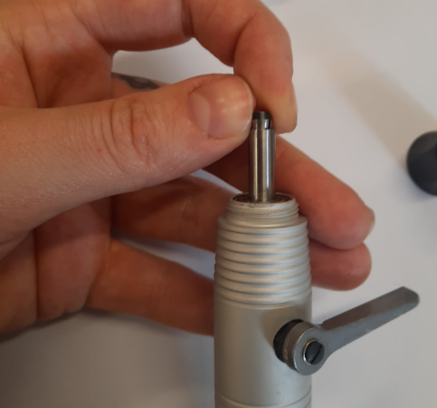

- Once the collet is changed or loosened/tightened to desired amount, insert the allen key back into the collet, and tighten the internal screw by turning clockwise. You will feel the screw bottom out. Do not overtighten.
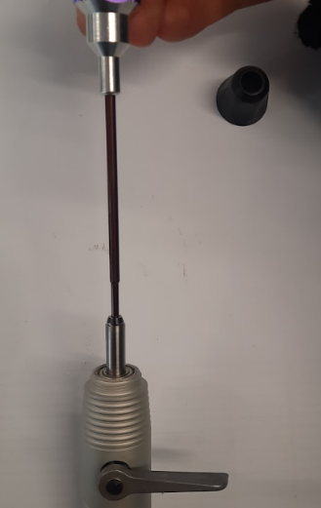

- At this point you are able to close the lever to the down position, screw the black cone back on and remove the pin from the base of the handpiece.

